CSE 581

**Lab 14: Error Handling**

1. Create a stored procedure: The SP should accept 2 parameters (let’s say A and B) and return the result of A divided by B. The SP should do error handling[1], and if an error occurs, it should print out *“An error has occurred”* and ***return*** -1 as a result.

CREATE PROCEDURE MyProcedure

(

@valX FLOAT,

@valY FLOAT

)

AS

DECLARE @ans FLOAT

BEGIN TRY

SET @ans = @valX/@valY

END TRY

BEGIN CATCH

PRINT 'An error has occurred'

SET @ans = -1

END CATCH

RETURN @ans

1. Execute the SP with input A = 10, B = 2. Verify that the result and error message are as expected.

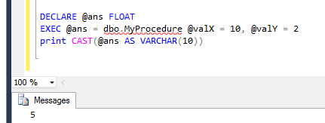

1. Execute the SP with input A = 10, B = 0. Verify that the result and error message are as expected.

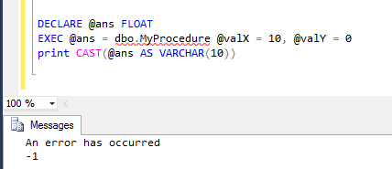

1.